EXPERIMENT 1 : PROCESS CREATION

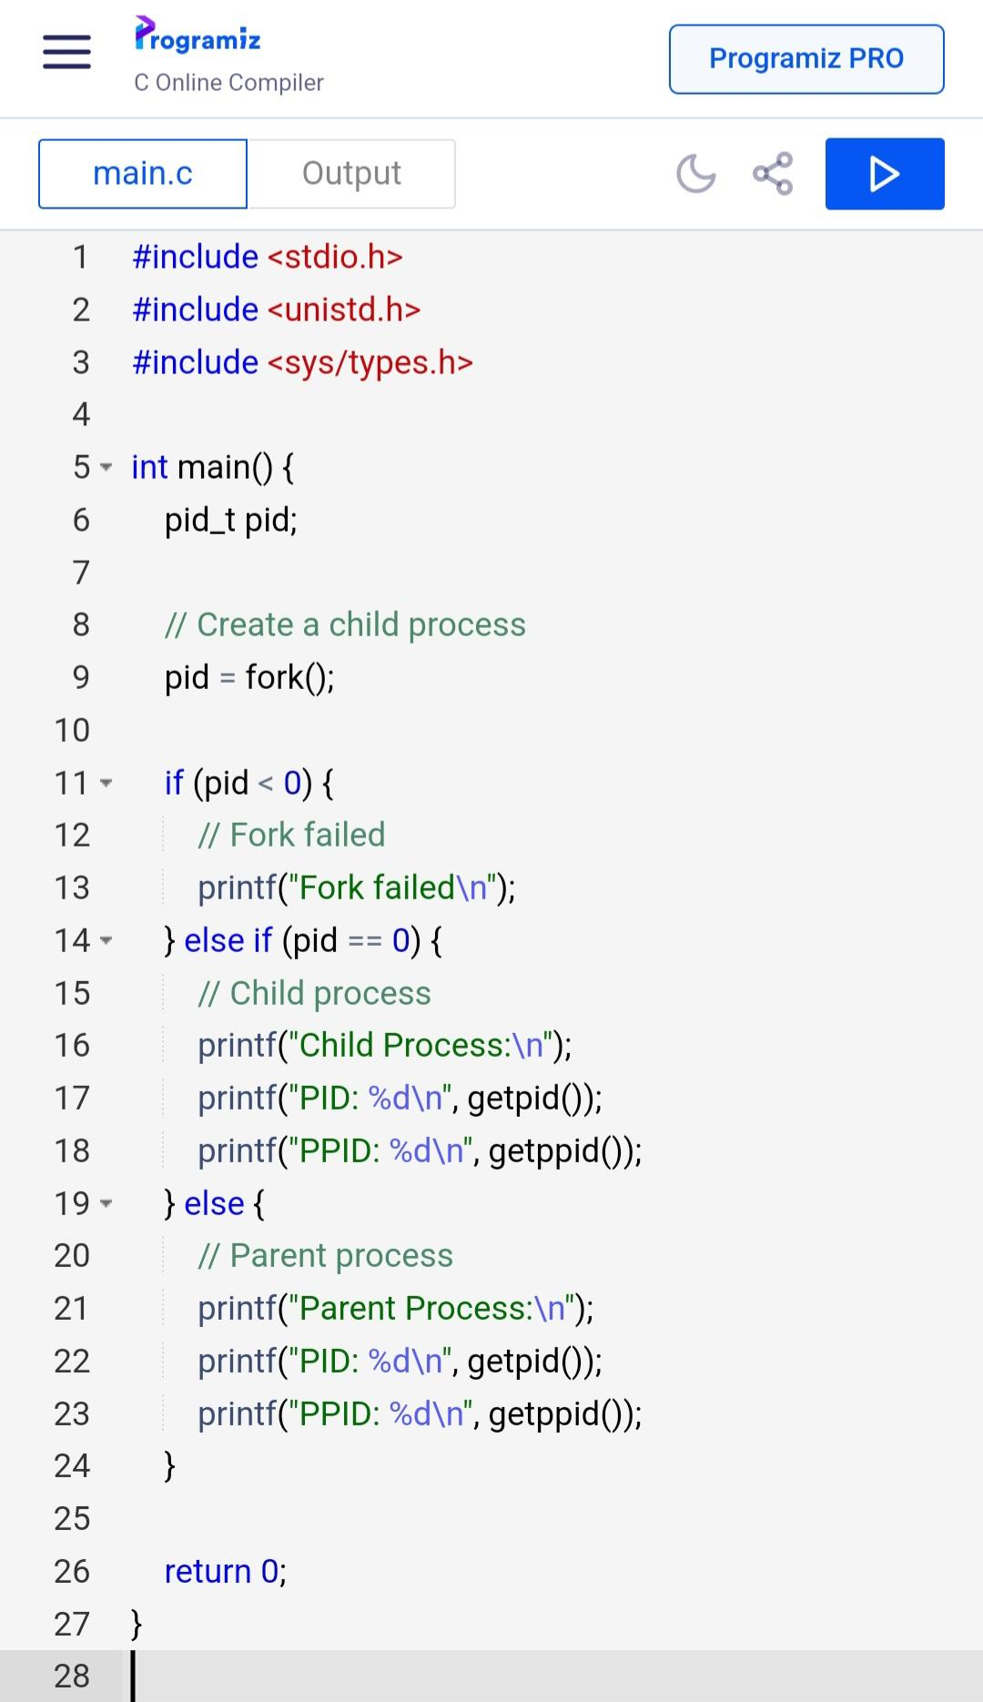

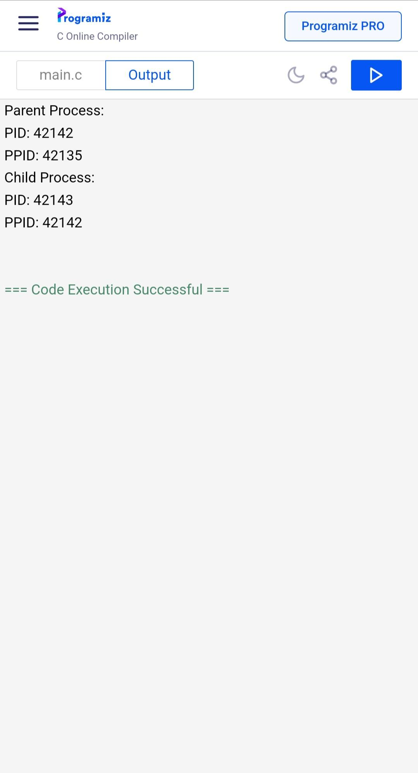

EXPERIMENT 2 : FILE COPYING

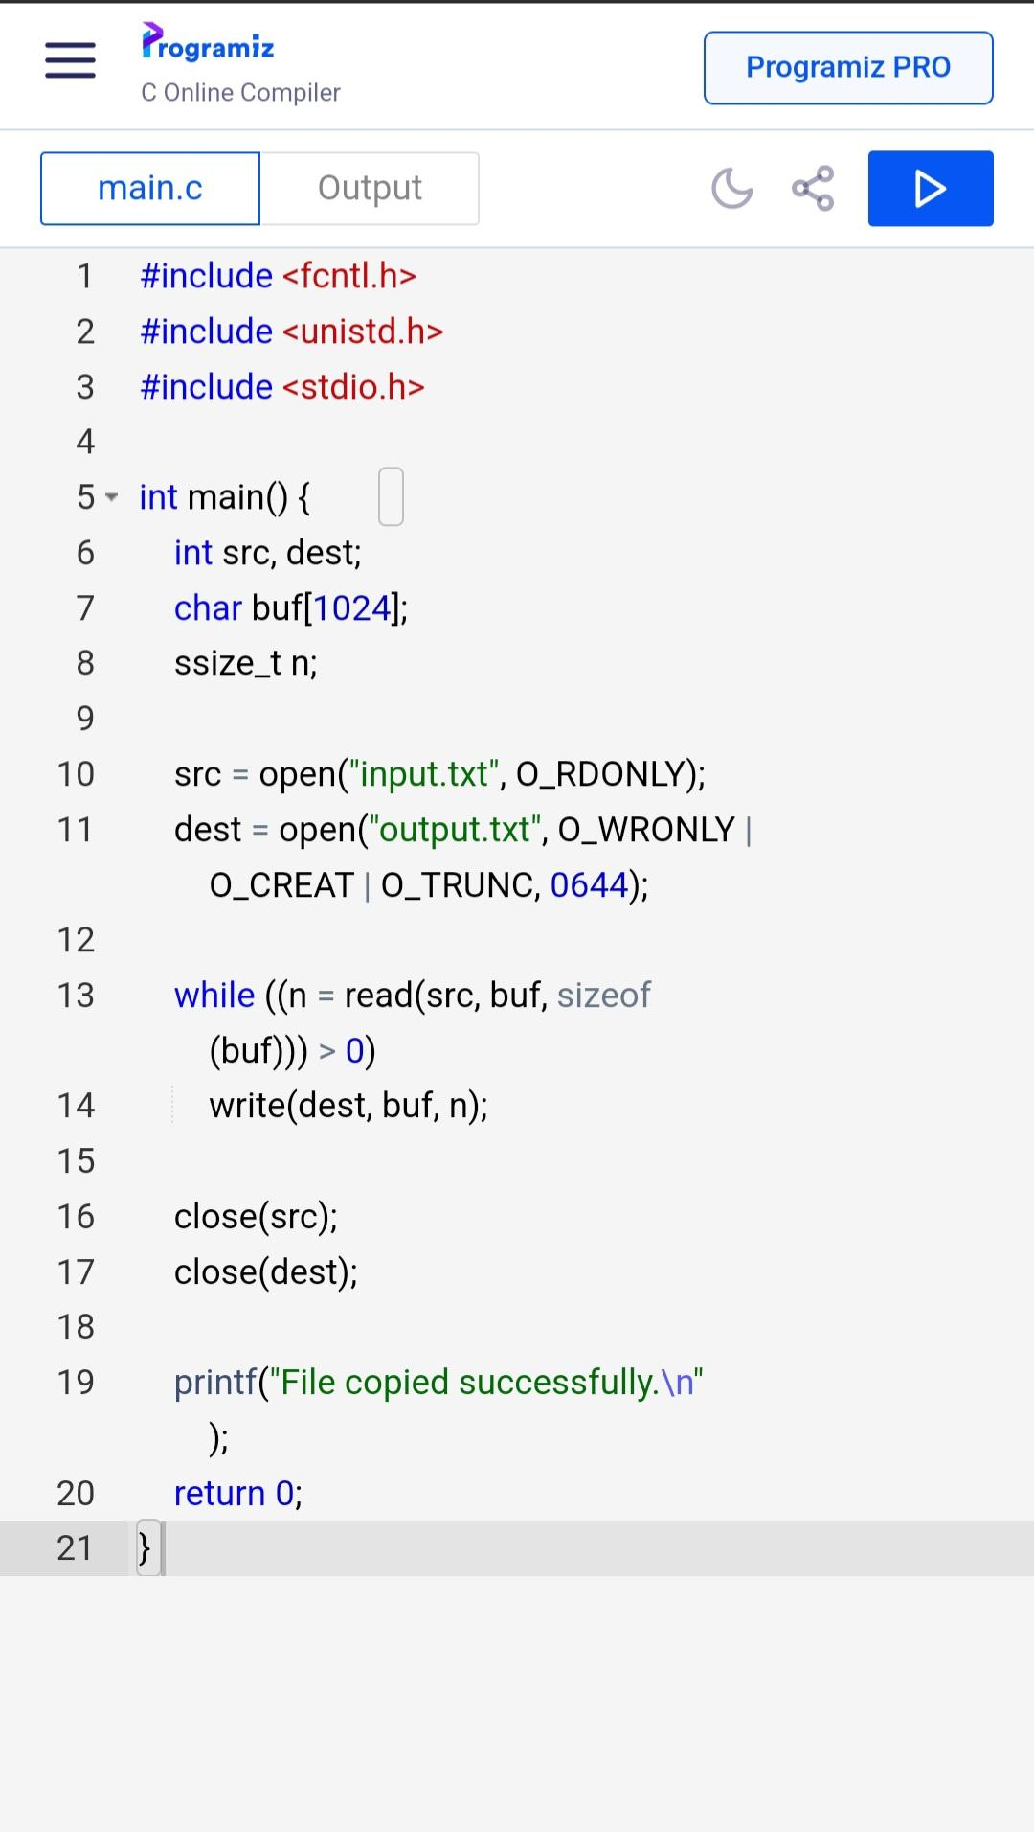

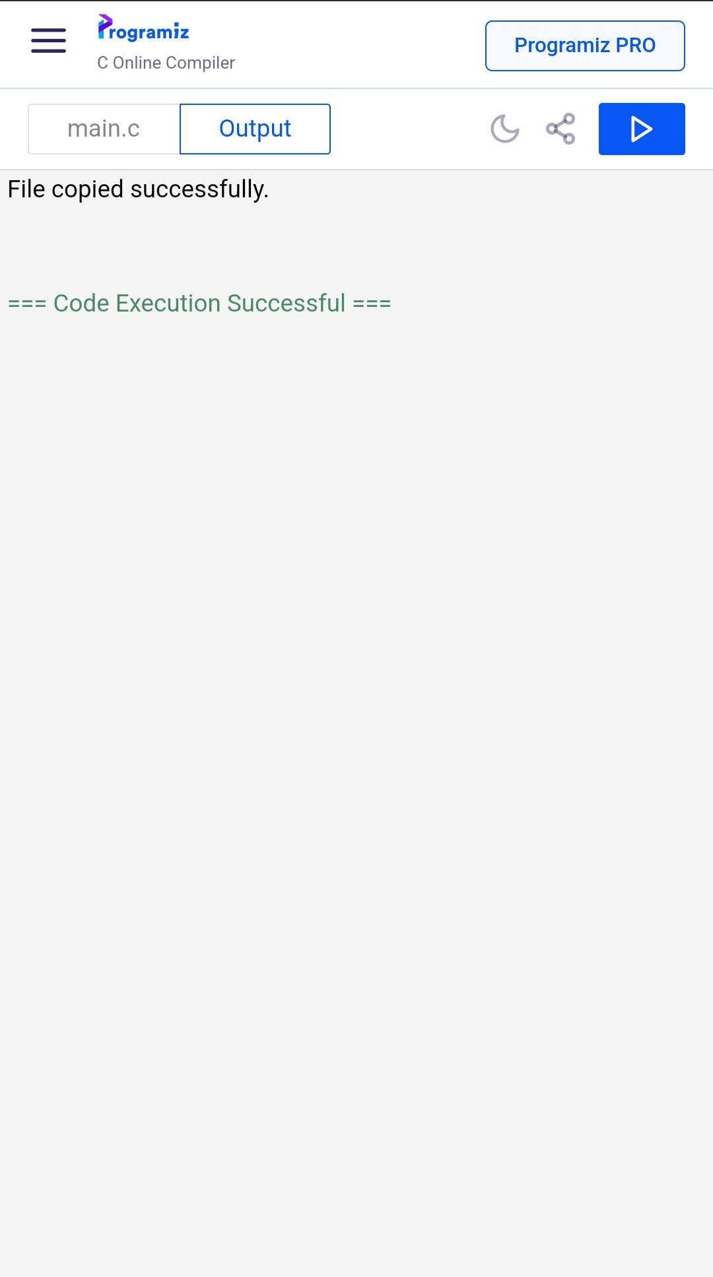

EXPERIMENT 3 : FCFS SCHEDULING

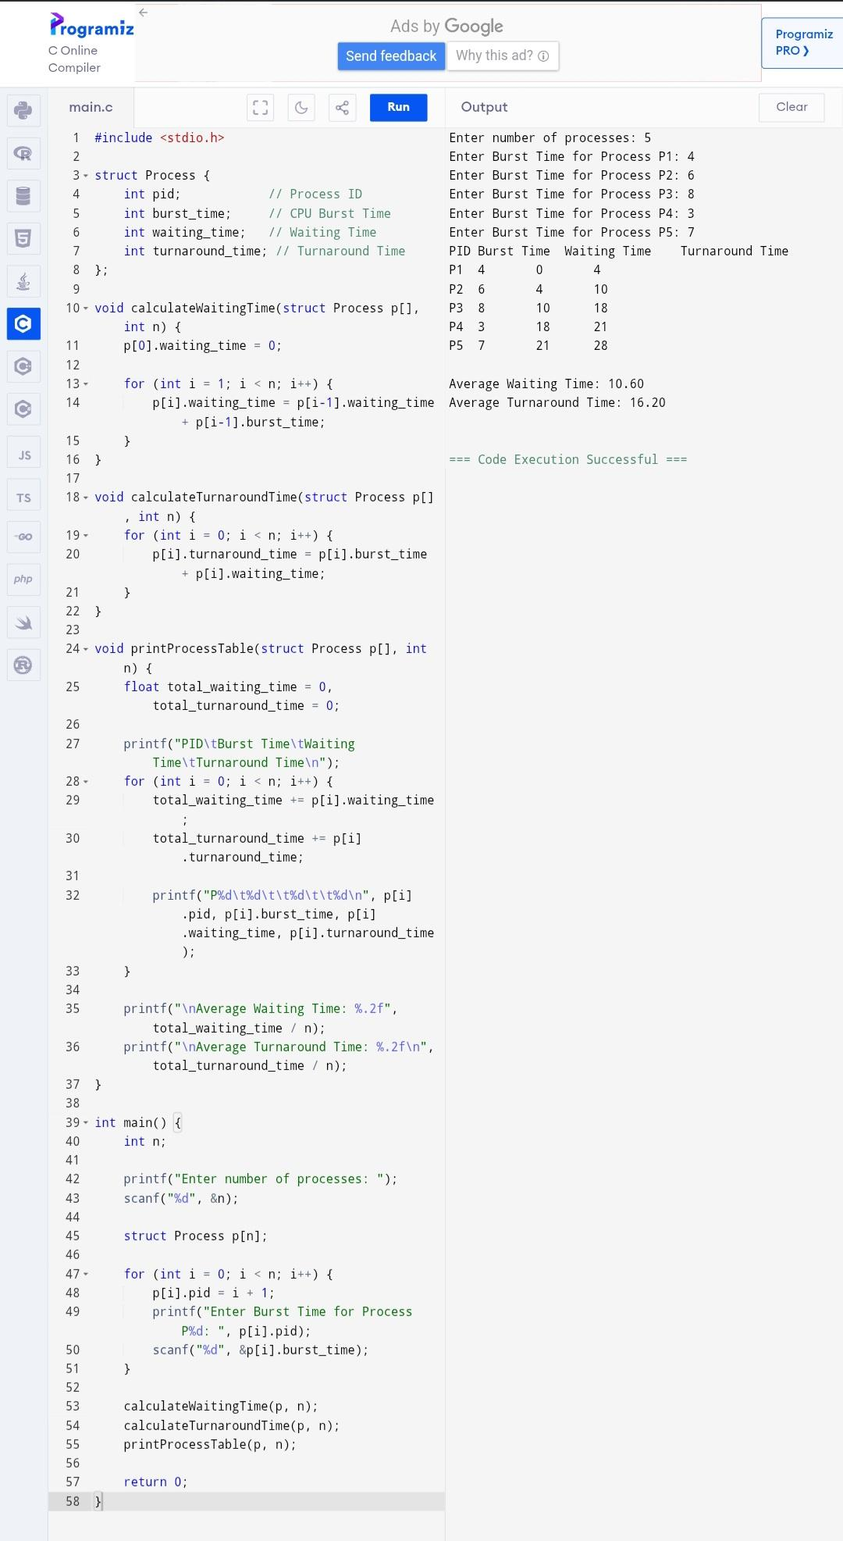

EXPERIMENT 4 : SJF SCHEDULING

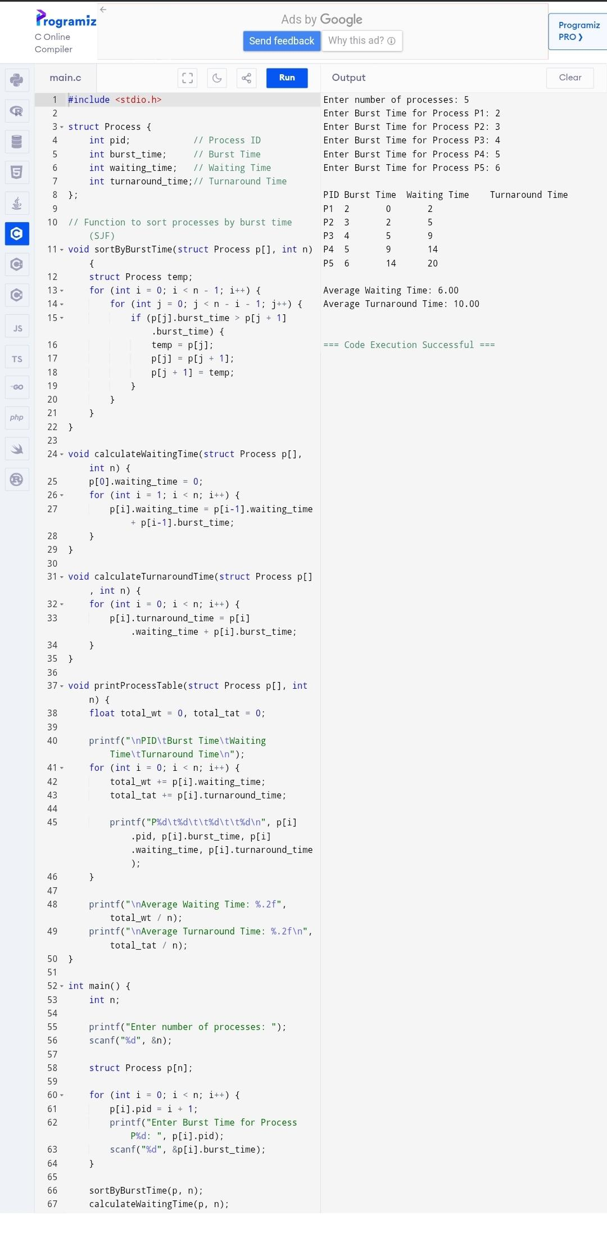

EXPERIMENT 5 : PRIORITY SCHEDULING

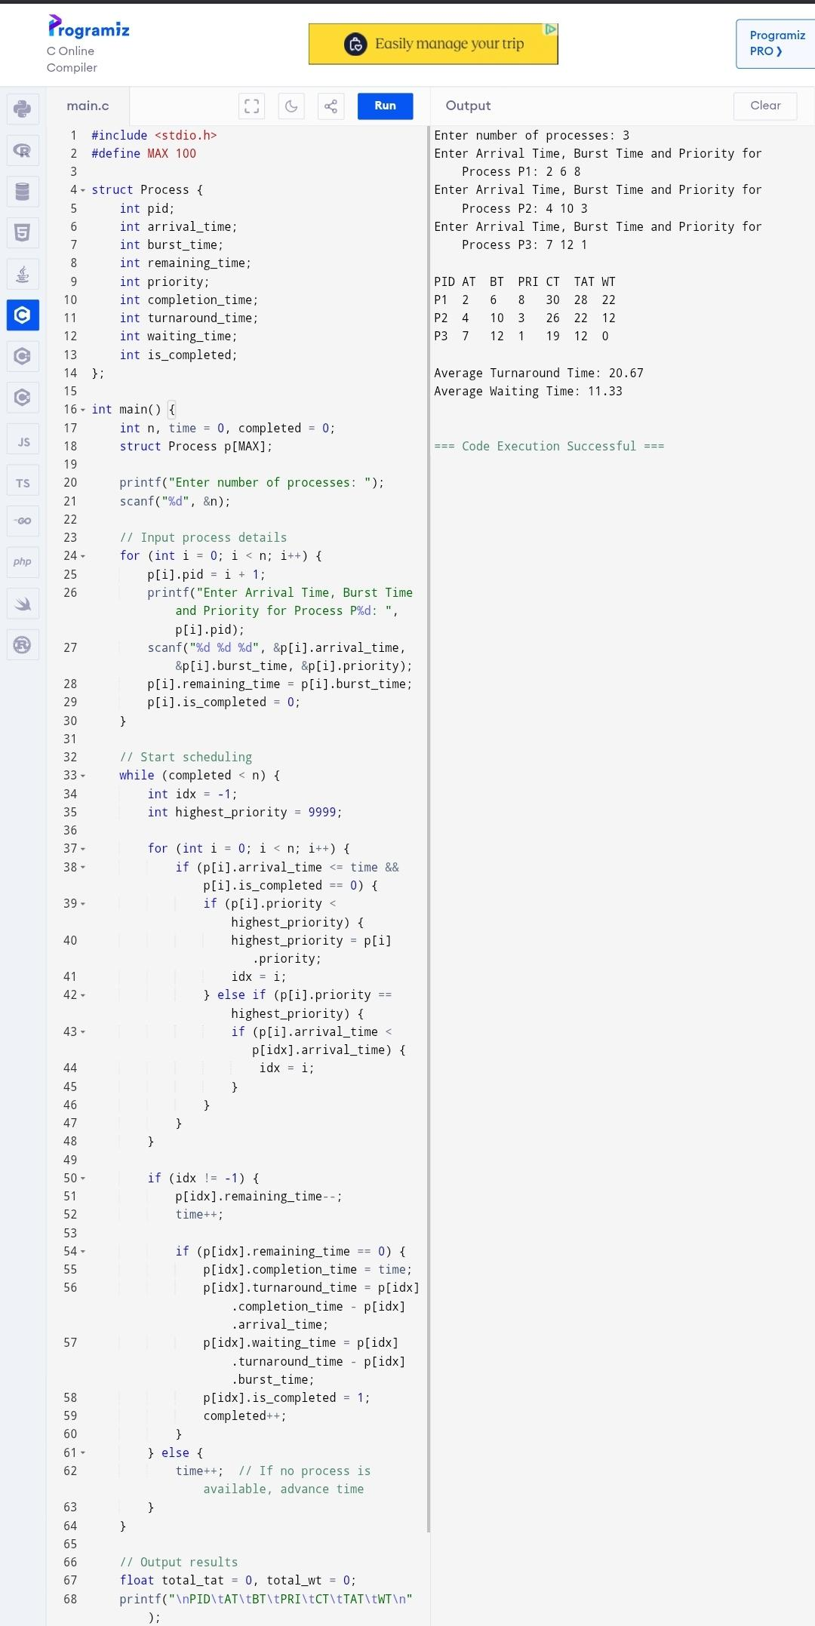

EXPERIMENT 6 : ROUND ROBIN SCHEDULING

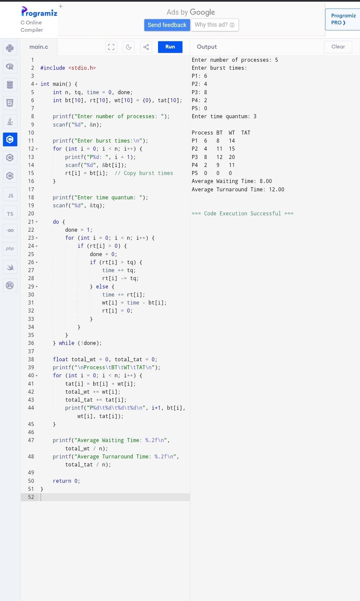

EXPERIMENT 7 : INTER PROCESS COMMUNICATION

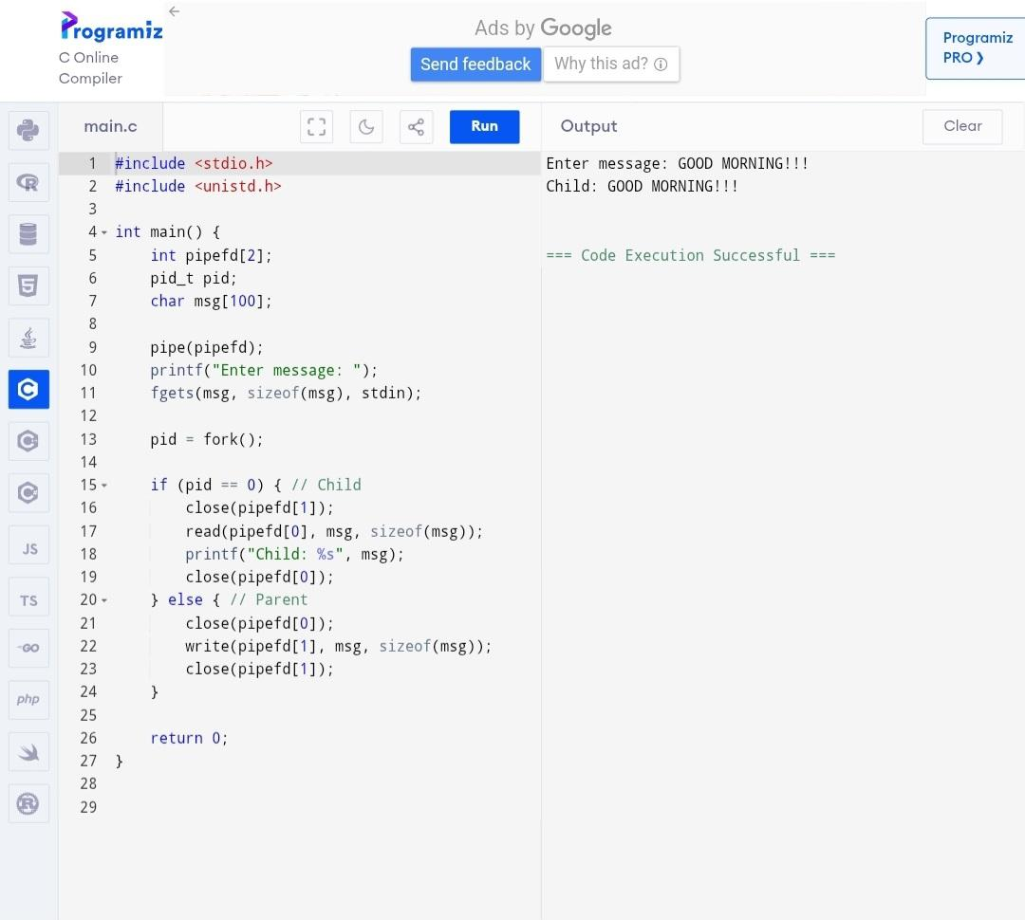

EXPERIMENT 8 : DINING PHILOSOPHERS PROBLEM

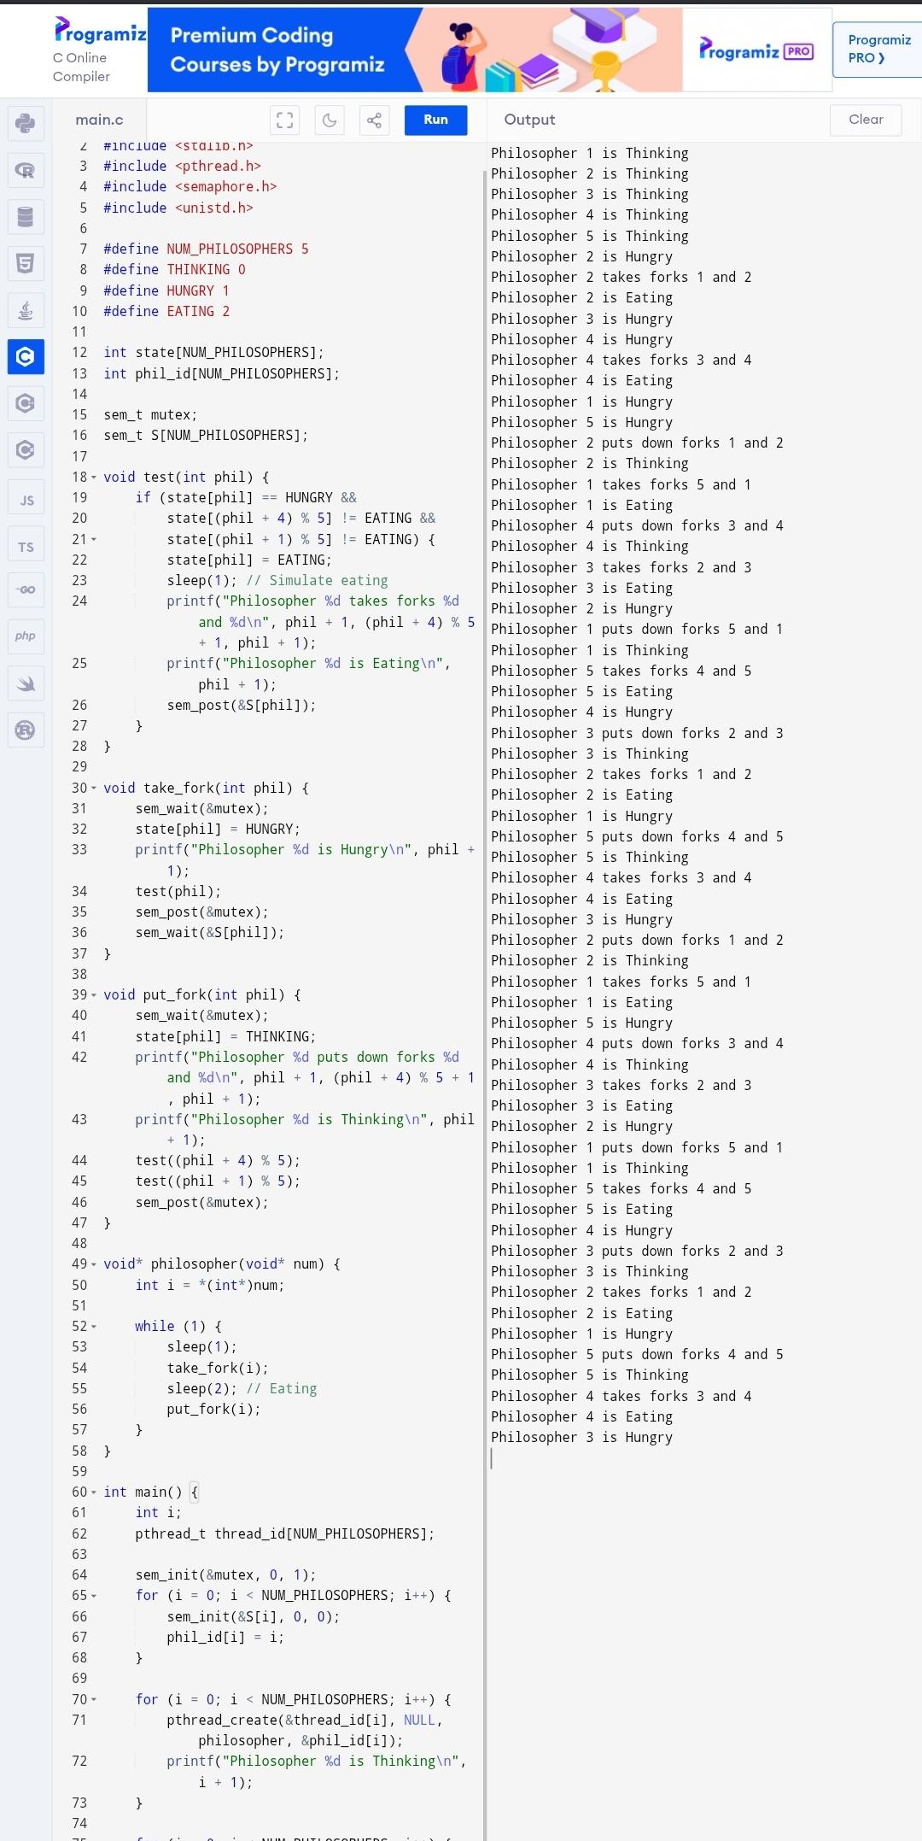

EXPERIMENT 9 : BANKER'S ALGORITHM

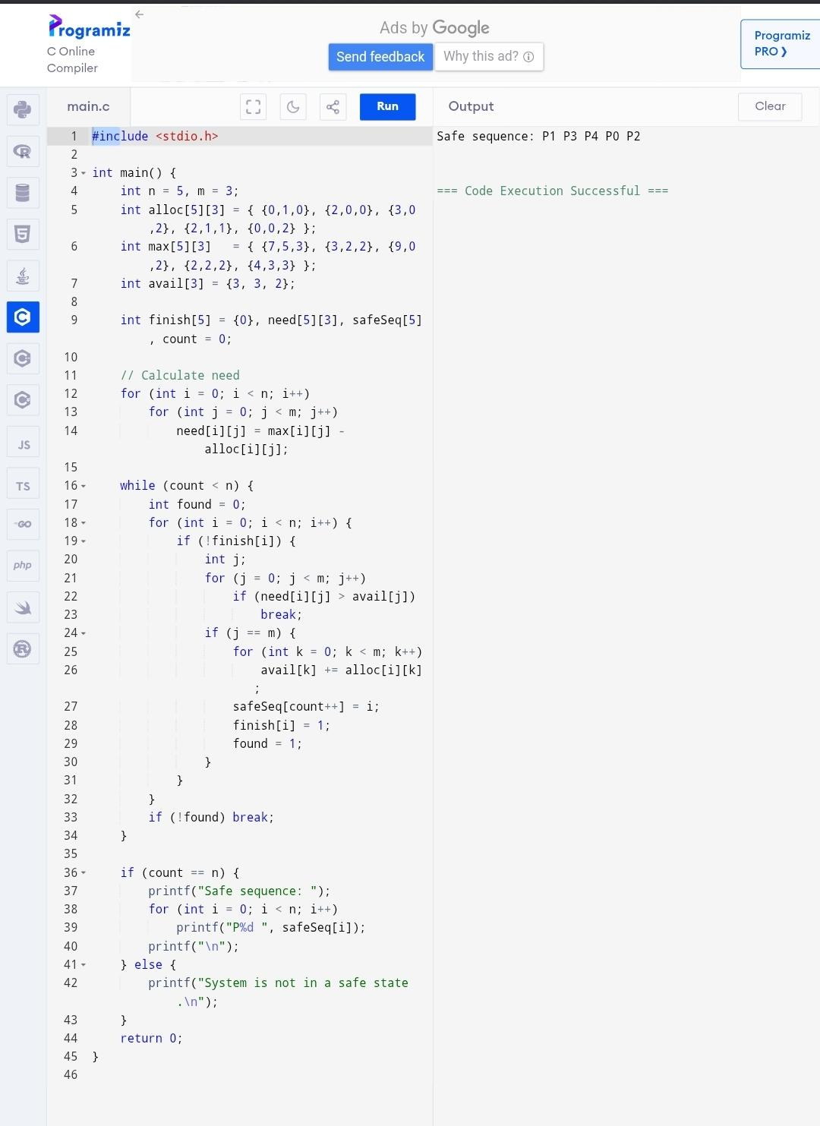

EXPERIMENT 10 : PRODUCER CONSUMER PROBLEM

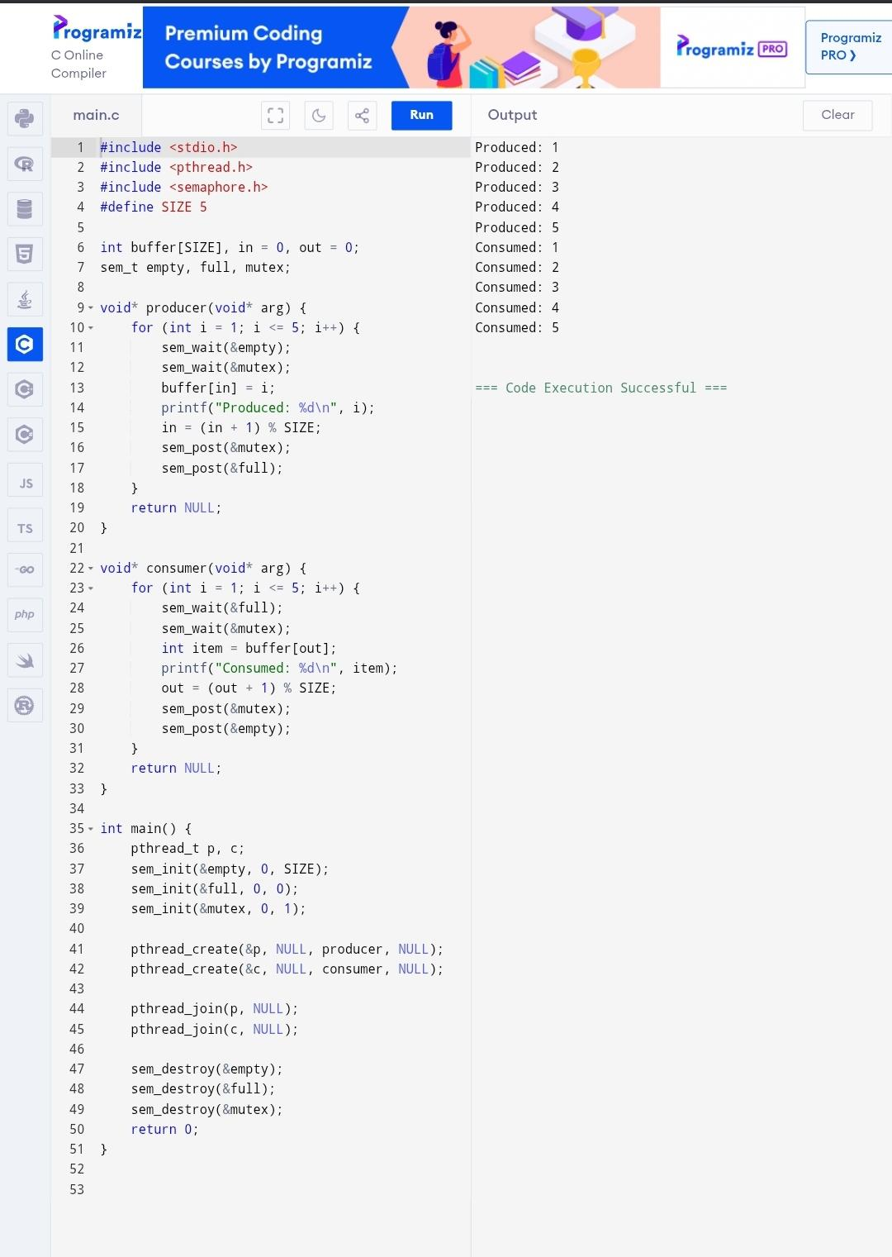

EXPERIMENT 11 : MULTI THREADING

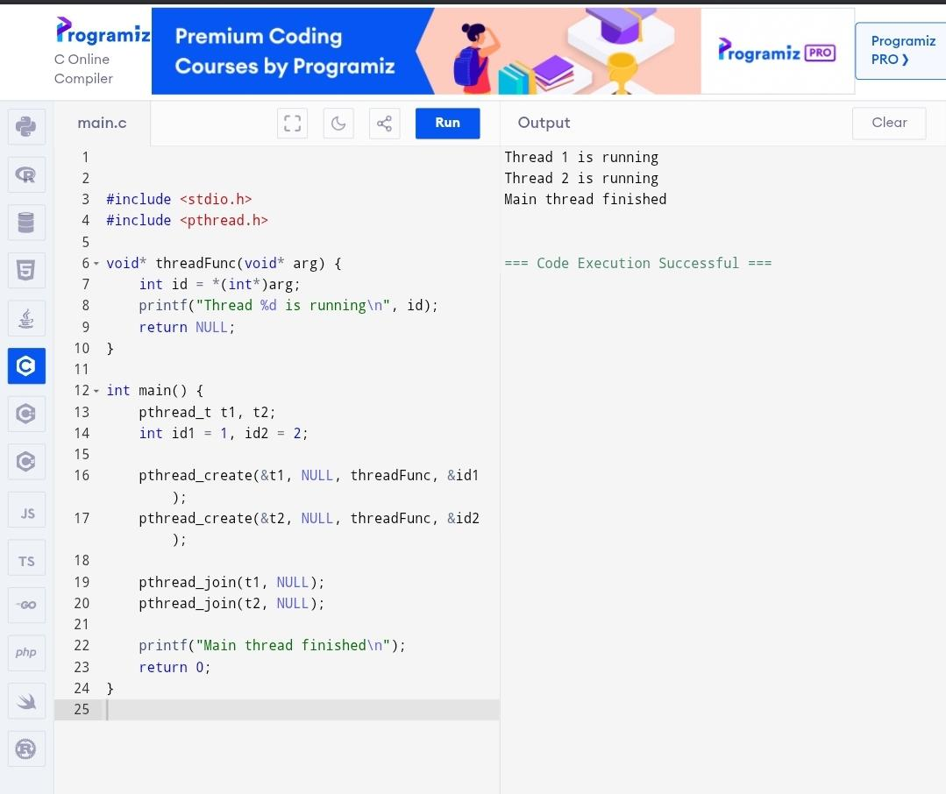

EXPERIMENT 12 : FIFO PAGING

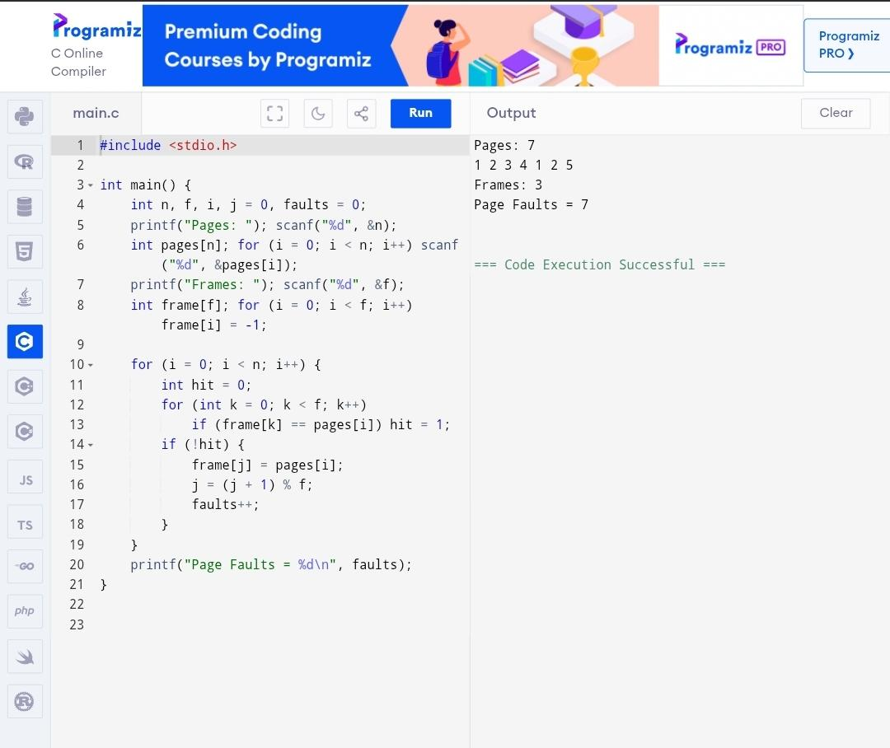

EXPERIMENT 13 : LRU PAGING

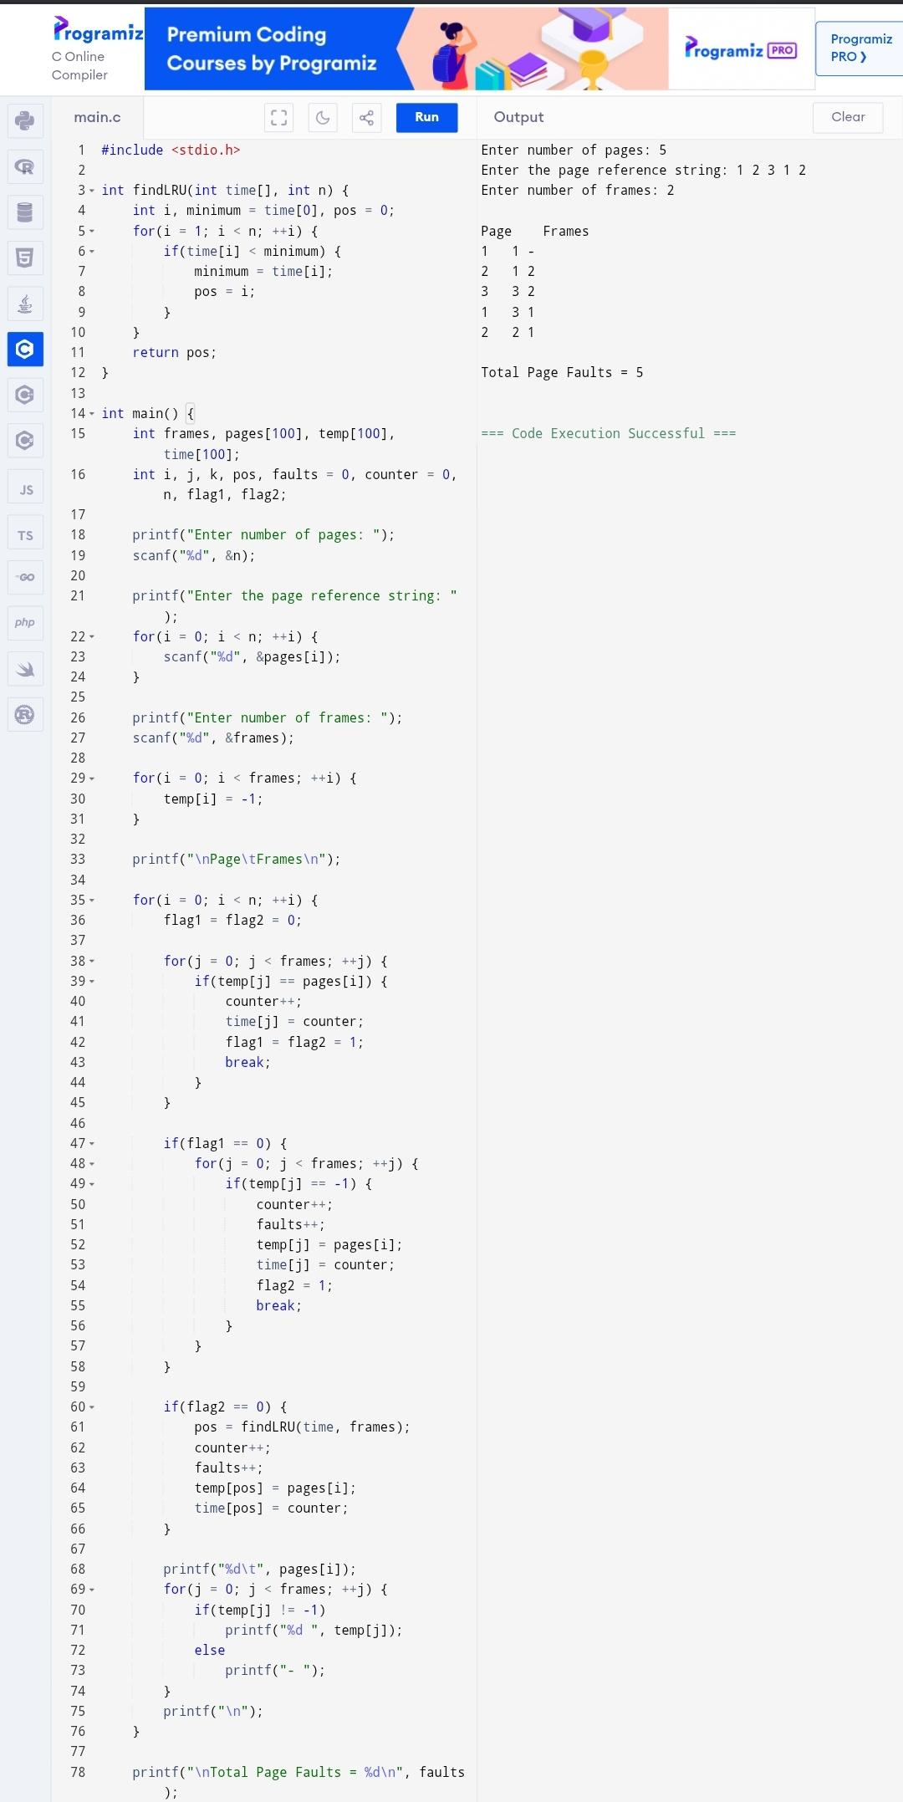

EXPERIMENT 14 : OPTIMAL PAGING

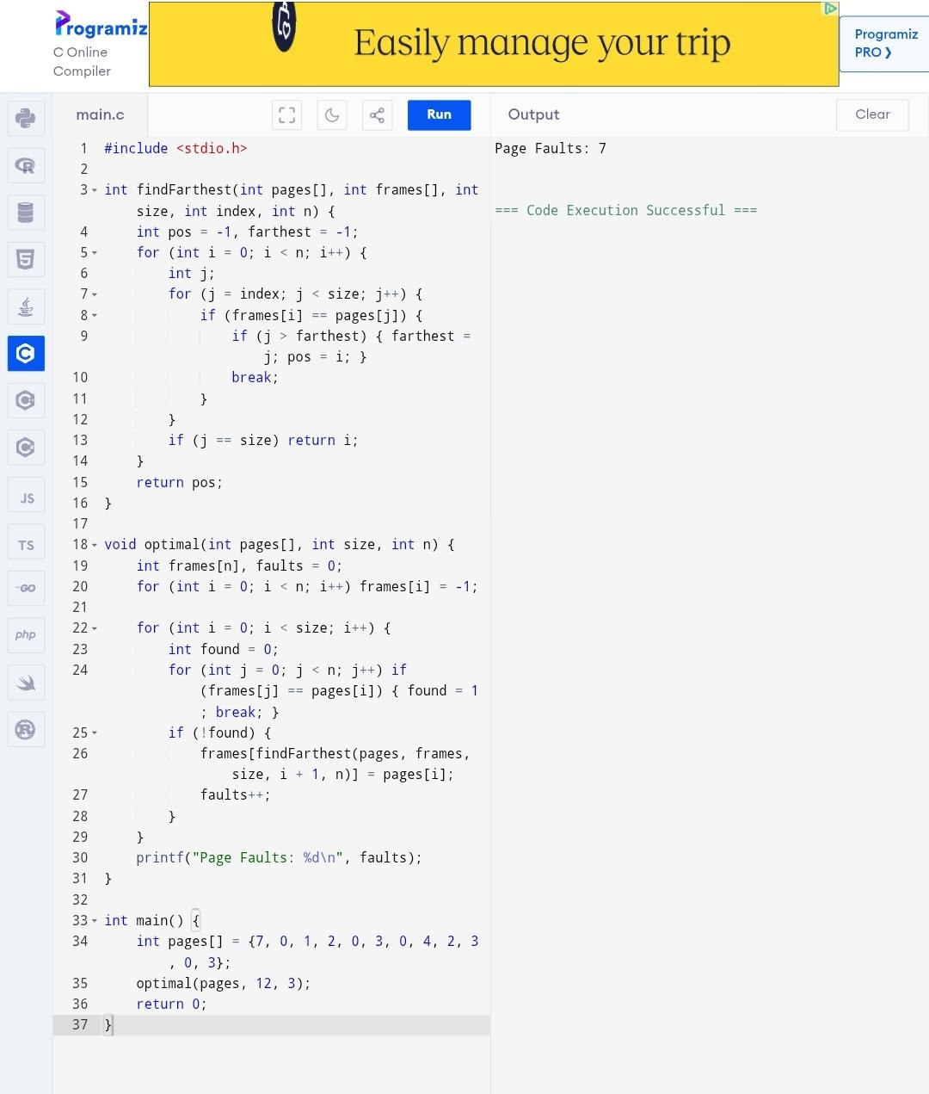

EXPERIMENT 15 : SEQUENTIAL FILE ALLOCATION

